15.Create a Snapshot of a VM and Test it by loading the Previous Version/Cloned VM

Step 1:Create

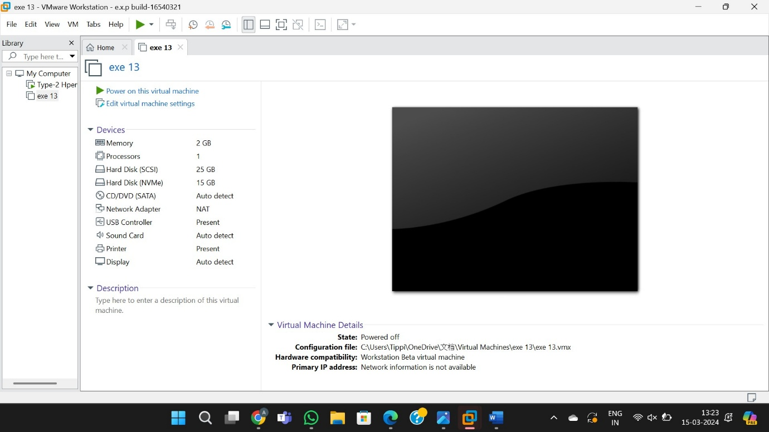

Step 2:Creating the snapshots of 4 by the description for memorize and removing allocated harddisk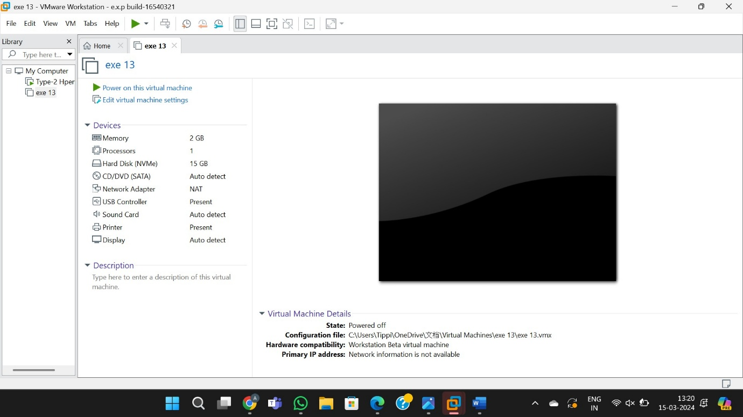

Step 3: Taking back to snap shot 1

